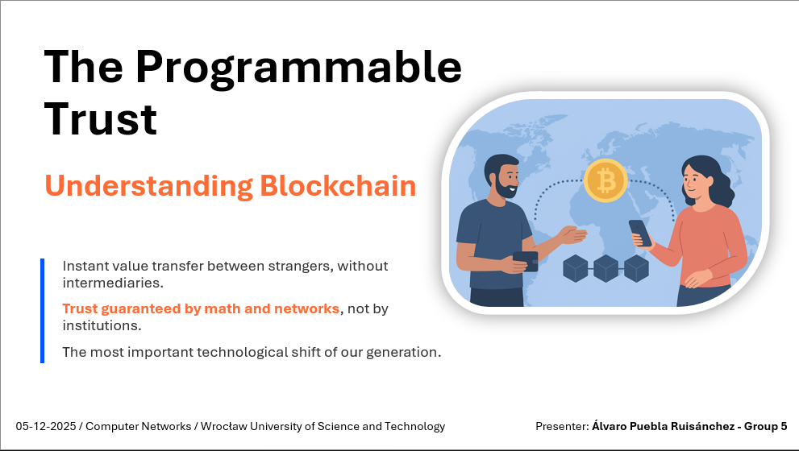
Presenter Notes:
"Imagine a world where trust doesn't depend on a bank or government, but on mathematics and code. This is the promise of blockchain technology.
Over the past few years, we've seen an explosion of cryptocurrencies and digital assets.
But beneath all the hype and speculation lies a fascinating technology that is fundamentally changing how we establish trust in digital systems.
My name is Álvaro Puebla and today, I want to take you on a journey to understand what blockchain really is, how it works, and why it matters."

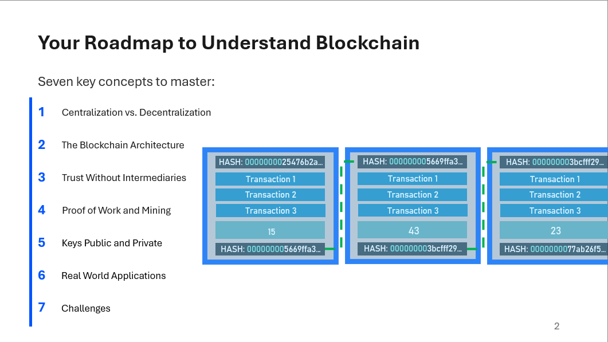
Presenter Notes:
"We have a lot of ground to cover, so let me give you a roadmap.
First, we'll understand why decentralization is important and what problems it solves.
Then, we'll dive into the technical architecture, how blocks are created, linked together, and secured.
Next, we'll explore the ingenious mechanisms that allow strangers to agree on a single truth without a central authority.
We'll see how mining and Proof of Work make the network secure.
Then, we'll look into the inner workings of cryptography.
Finally, we'll explore real-world applications and their challenges."

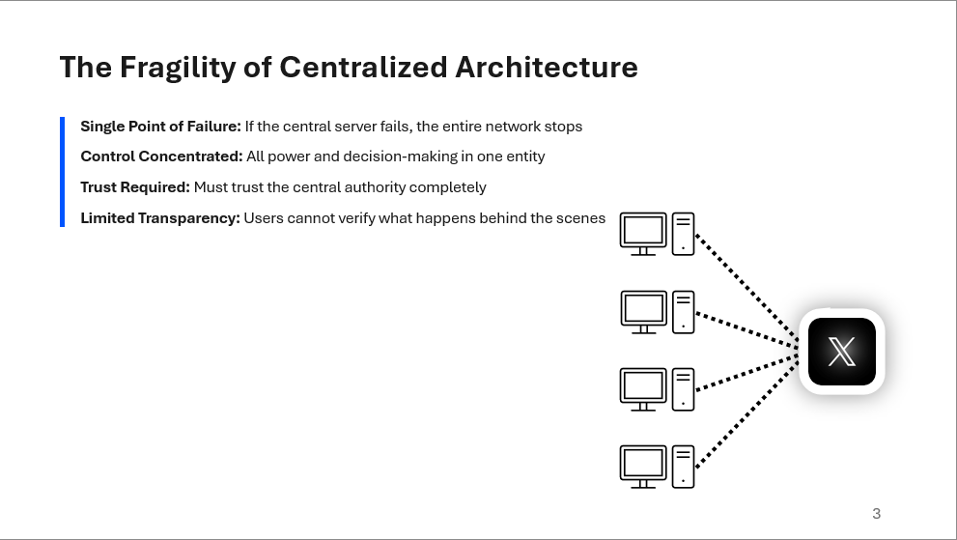
Presenter Notes:
"Let's start with a problem we all know too well. Remember when CloudFlare went down? Or when Amazon had an outage?
This happens because these services rely on centralized architecture.
All users connect to central servers controlled by a single company. If those servers fail, the entire network fails. But the problem goes deeper than just reliability.
In a centralized system, all power and control are concentrated in one entity. That entity decides the rules, manages the data, and can manipulate transactions.
We must trust them completely. This is fine for some applications, but for financial systems, voting, or identity management, this concentration of power is problematic.
What if there was a better way?"

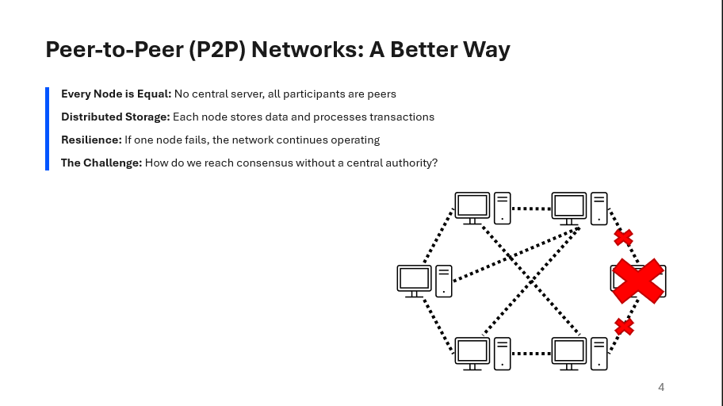
Presenter Notes:
"The alternative is a peer-to-peer, or P2P, network. In a P2P network, every computer is equal.
There's no central server. Each node stores data, processes transactions, and communicates directly with other nodes.
If one node fails, the network keeps working.
You've probably used P2P technology before, BitTorrent works this way.
When you download a file from BitTorrent, you're not downloading from a central server.
Instead, you're downloading pieces from other computers in the network, and simultaneously, others are downloading pieces from you.
This is resilient and censorship-resistant.
But here's the challenge: how do we coordinate? How do we agree on what's true when there's no central authority to decide? This is where blockchain comes in."
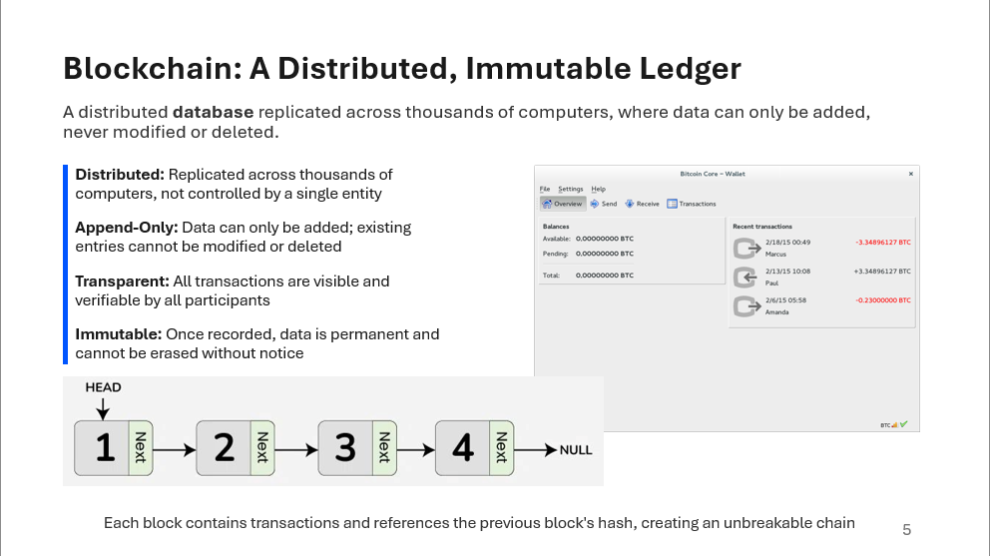
Presenter Notes:
"Blockchain is essentially a distributed, append-only ledger.
Think of it as a shared notebook that is replicated across thousands of computers. When a new transaction occurs, it's added to this ledger.
The key feature is that it's append-only—you can only add new entries, you cannot modify or delete existing ones.
This immutability is crucial. Once something is recorded, it's permanent. And because the ledger is distributed, everyone has a copy. Everyone can verify the history.
This creates transparency without requiring a central authority.
For a digital currency like Bitcoin, the currency itself is not a file or a coin. It's the record of all transactions.
If I have 10 bitcoins and I send 2 to someone else, that transaction is recorded in the ledger. Everyone can verify that I had those bitcoins and that I transferred them."
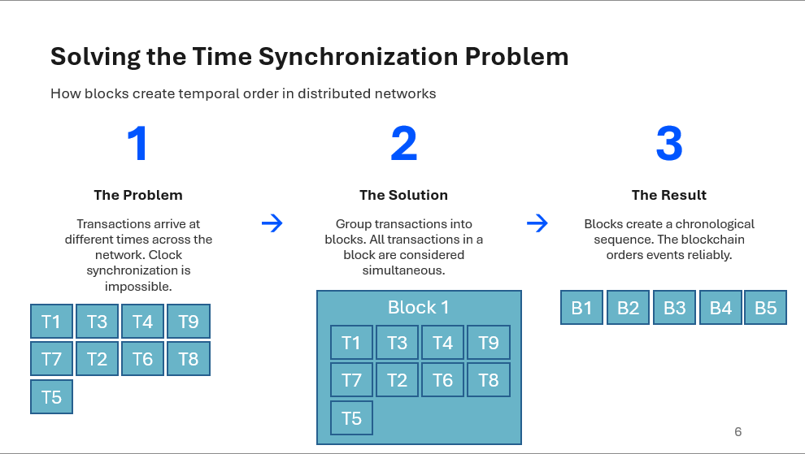
Presenter Notes:
"Here's a problem that's often overlooked: in a distributed network, how do we agree on the order of events?
Transactions are happening simultaneously across the network. They arrive at different nodes at different times.
You might think we could synchronize clocks, but that's impossible in a distributed system.
Each computer has its own clock, and synchronizing them requires communication, which also takes time.
The solution is the block. Instead of trying to order individual transactions, we group them into blocks.
A block is a batch of transactions that occurred during a specific time window. All transactions within a block are considered to have occurred at roughly the same time.
This solves the ordering problem. The blockchain then orders the blocks, creating a chronological sequence of events."
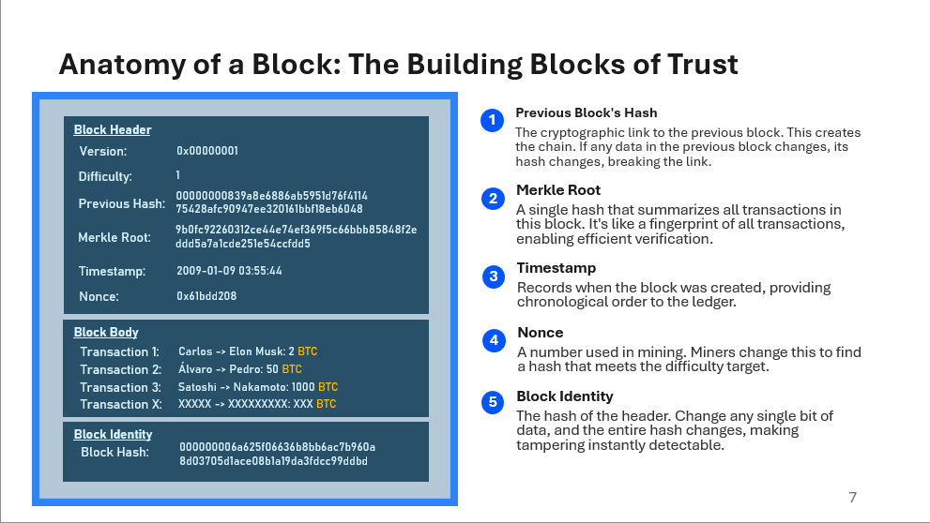
Presenter Notes:
"A block is more than just a batch of transactions — it has a header and a body. The body holds the list of transactions; the header contains the previous block's hash, a timestamp, a difficulty target, a nonce, and the Merkle root (a single hash summarizing all transactions). The Merkle tree lets any node prove that a particular transaction is included without downloading every transaction. The previous-block hash links blocks together so any change in an earlier block invalidates all later blocks. Together, grouping transactions into blocks and linking headers solves the ordering problem and creates an auditable, append-only history."

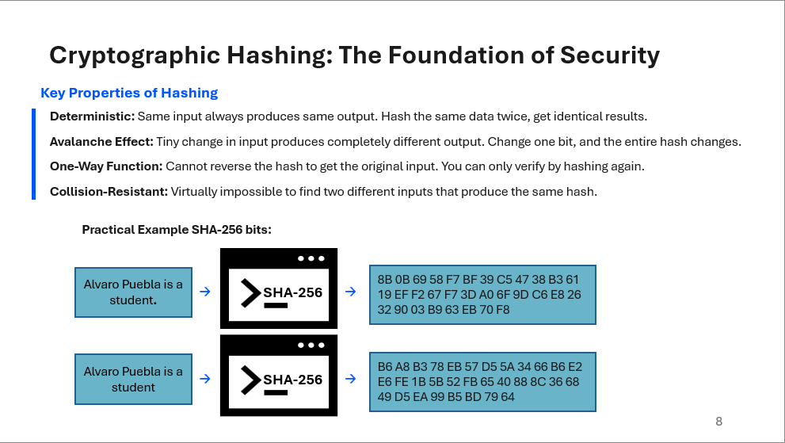
Presenter Notes:
"To understand how blockchain is secure, we need to understand cryptographic hashing.
A hash function takes any input (a file, a number, a block of data) and converts it into a fixed-size output.
Bitcoin uses SHA-256, which produces a 256-bit hash.
Here are the key properties.
- First, it's deterministic: if you hash the same input twice, you get the same output.
- Second, it has the avalanche effect: if you change even a single bit of the input, the output changes completely. This is crucial for security.
- Third, it's one-way: you cannot reverse the hash to get the original input.
- Fourth, it's collision-resistant: it's virtually impossible to find two different inputs that produce the same hash.
These properties make hashing perfect for creating tamper-evident records."

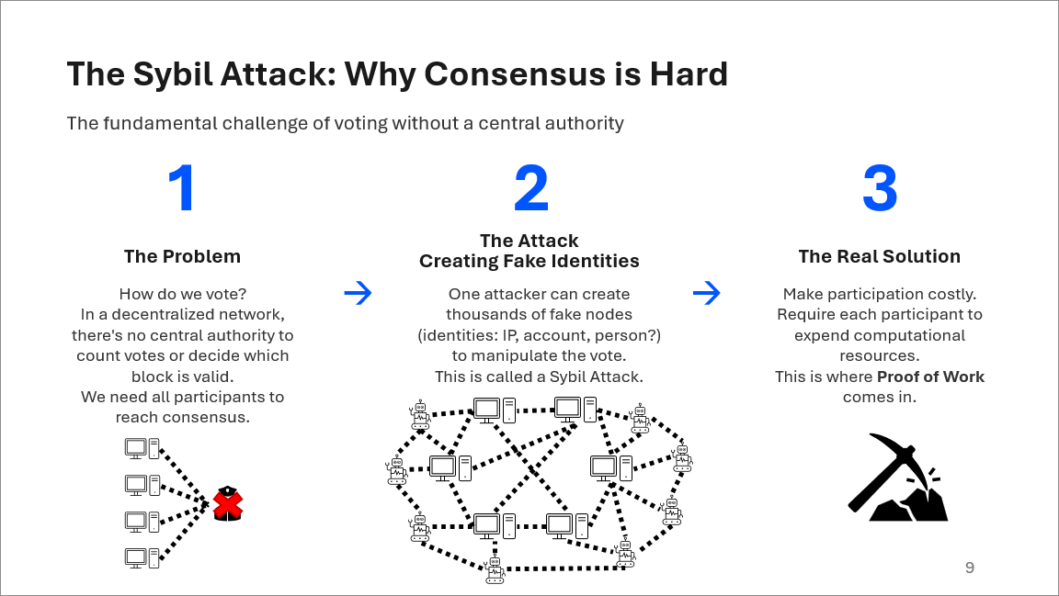
Presenter Notes:
"A Sybil attack happens when a single adversary creates many fake identities or nodes to gain disproportionate influence in the network. In an open P2P system, identities are cheap to create, so without safeguards an attacker could flood the network with fake peers. This doesn’t let them break cryptography or rewrite the chain, but it does let them manipulate how information flows: they can isolate victims, delay or suppress blocks and transactions, or distort peer discovery.
Blockchains mitigate this with resource-based identity: in Proof-of-Work, influence depends on hashing power, not the number of node identities. Running thousands of fake nodes is easy; running thousands of miners is not. Networks also reduce Sybil exposure with peer-connection limits, reputation scoring, and diversified peer selection. The key point: Sybil attacks exploit free identity creation, and blockchains defend against them by tying influence to costly resources."

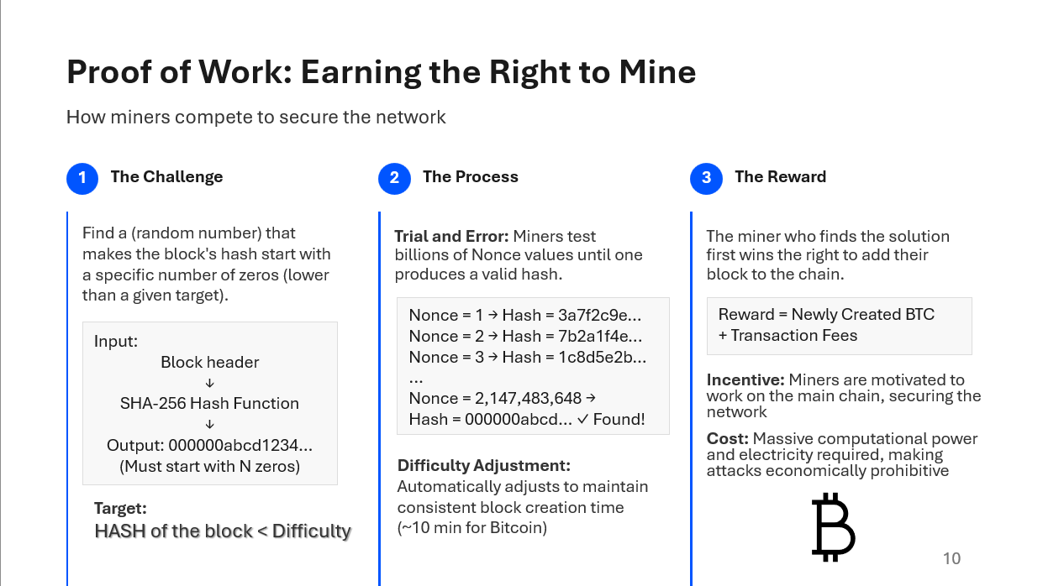
Presenter Notes:
"So, how do we make participation costly? Through Proof of Work.
The idea is simple: to add a block to the chain, you must solve a cryptographic puzzle.
The puzzle works like this: you take the block data and a random number called a Nonce.
You hash them together using SHA-256. The goal is to find a Nonce that makes the hash start with a specific number of zeros.
Let's say the target is 18 leading zeros. The only way to find this Nonce is through trial and error.
You try billions of combinations until you find one that works. This requires massive computational power.
The miner who finds the solution first wins the right to add their block to the chain and receives a reward: newly created bitcoins and transaction fees.
This is why it's called mining, miners are competing to solve the puzzle, and the winner gets rewarded.
The difficulty of the puzzle adjusts automatically to maintain a consistent block creation time, roughly every 10 minutes for Bitcoin."

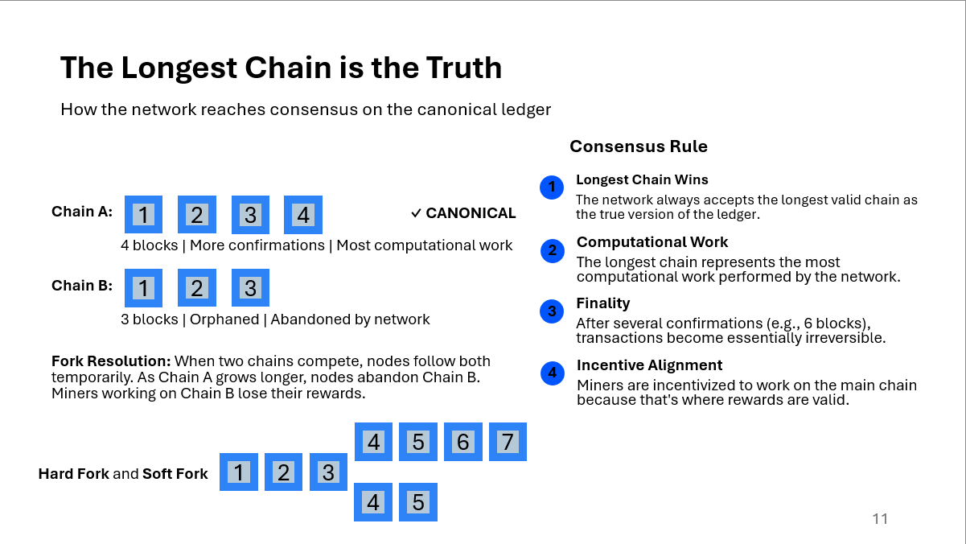
Presenter Notes:
"Here's the consensus rule: the network always accepts the longest valid chain as the true version of the ledger. Why the longest chain? Because it represents the most computational work. If two miners find blocks at roughly the same time, there might be two competing chains. Nodes will follow both chains temporarily, but as more blocks are added, one chain will become longer. Nodes will then abandon the shorter chain and follow the longer one. This is called a fork resolution. The blocks in the abandoned chain are called orphaned blocks. The miners who created them don't get their reward. This incentive structure ensures that miners work on the main chain. After a block is buried under several more blocks, it becomes essentially irreversible. To change a transaction, an attacker would have to redo all the computational work for that block and all subsequent blocks, which is practically impossible."
Types of forks to be aware of:
• Accidental (temporary) forks — short-lived, resolved when one chain outgrows the other.
• Soft forks — backward-compatible rule tightening; old nodes still accept new blocks but may not enforce the new rules.
• Hard forks — rule changes that are not backward-compatible and require nodes to upgrade; can create two persistent chains if not universally adopted.

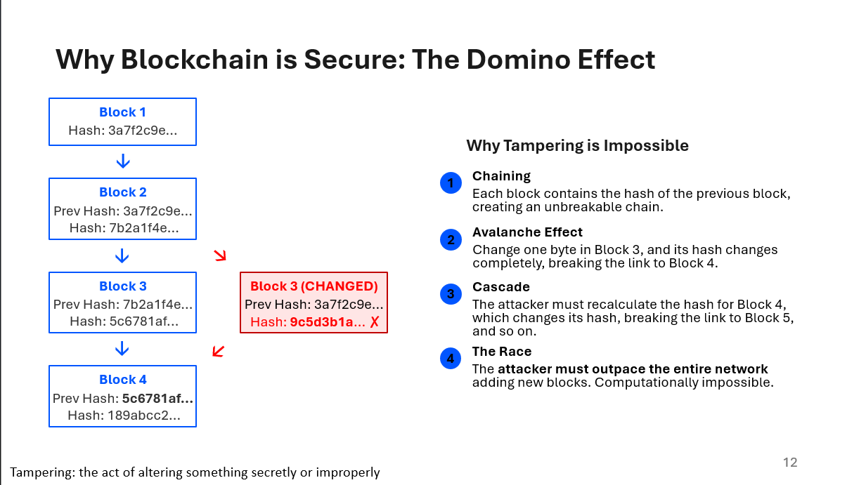
Presenter Notes:
"Now, here's why blockchain is secure. Each block contains the hash of the previous block.
This creates a chain. If an attacker tries to change a transaction in an old block, the block's hash changes.
This breaks the link to the next block. The next block's hash is now invalid.
So the attacker must recalculate the Proof of Work for the next block. But this changes its hash, breaking the link to the block after that.
And so on. It's a domino effect. The attacker must redo all the computational work for that block and every block that follows it.
Meanwhile, the rest of the network is continuing to add new blocks to the legitimate chain. The attacker must not only catch up but also outpace the network.
To do this, the attacker would need more than 50% of the network's total computational power. This is called a 51% attack. For large networks like Bitcoin, this is economically infeasible.
The computational power required would cost billions of dollars, and the attack would likely be detected and the network would respond."

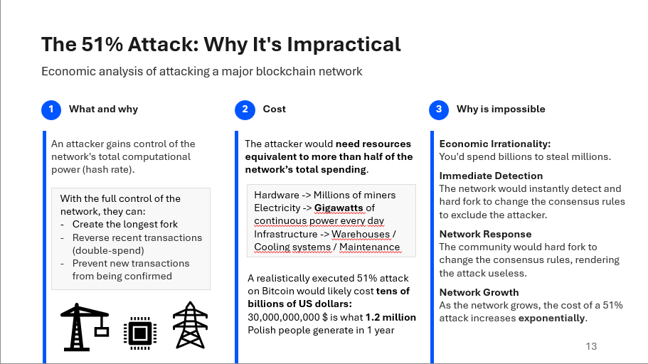
Presenter Notes:
"A 51% attack occurs when a single actor (or colluding group) controls a majority of the network's computational power. With majority hashing power an attacker can reorganize recent blocks to perform double-spends, censor transactions, or slow confirmations. While technically feasible, such attacks have important practical and economic constraints: acquiring and operating that much hardware is extremely costly; the attack erodes confidence and typically destroys the value of the currency the attacker is trying to defraud; detection is rapid and the community can respond. Countermeasures include: improving monitoring and alerts, temporary checkpoints, economic disincentives (penalizing detected double-spend gains), coordinated hard forks, and — in some ecosystems — switching consensus (e.g., to PoS) or changing mining parameters. Several smaller PoW chains have experienced 51% attacks in the past, illustrating the risk to less-secure networks; the risk is much smaller for large, well-distributed networks."
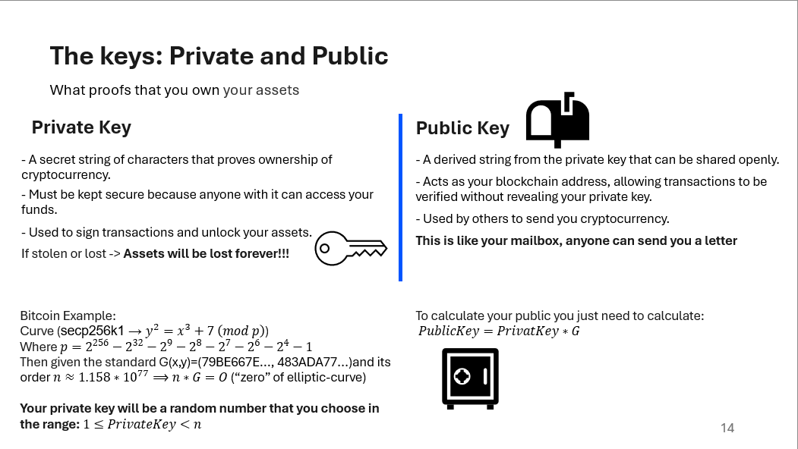
Presenter Notes:
TODO

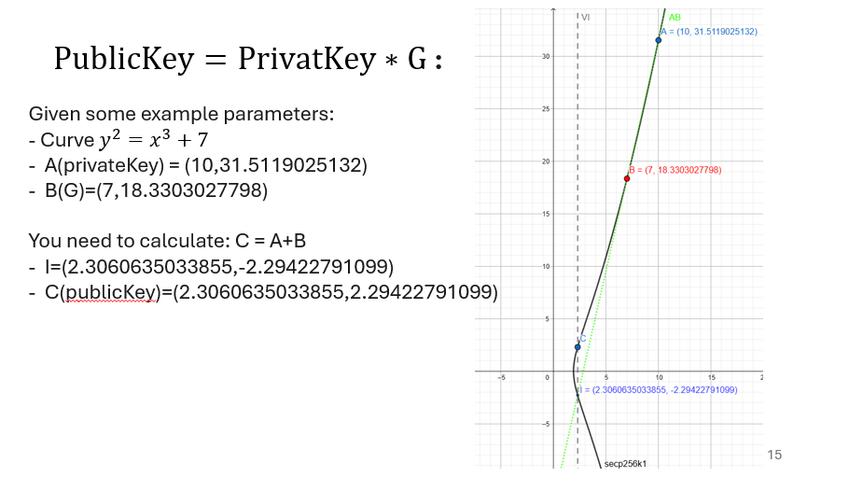
Presenter Notes:
TODO

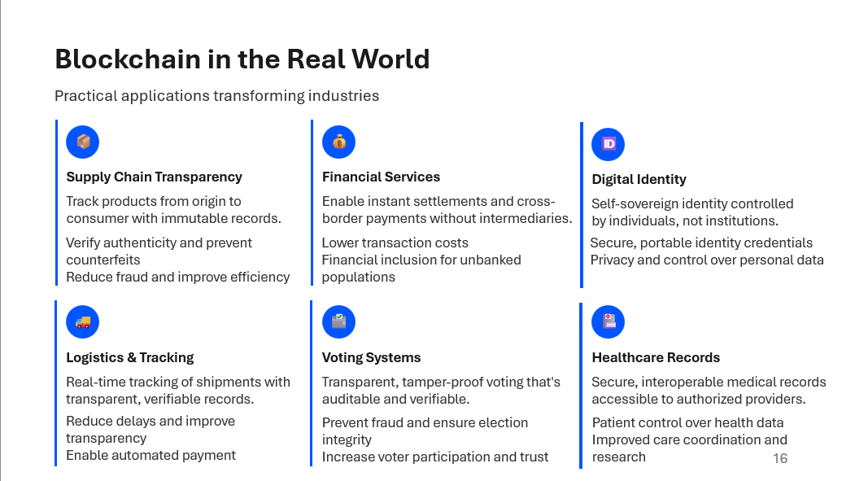
Presenter Notes:
"Now, let's look at real-world applications. Blockchain is not just about cryptocurrency. It's a technology that can be applied to many industries. In supply chain management, blockchain enables transparency. You can track a product from the factory to your hands, with immutable records at each step. This prevents counterfeiting and fraud. In finance, blockchain enables instant settlements and cross-border payments without intermediaries. This reduces costs and brings financial services to people who don't have access to traditional banks. In identity, blockchain enables self-sovereign identity—you control your credentials, not a government or corporation. In healthcare, blockchain can secure medical records and give patients control over their data. In voting, blockchain creates tamper-proof voting systems that are transparent and auditable. And in logistics, blockchain provides real-time tracking with transparent records. These are just examples. The underlying principle is the same: blockchain enables trust without intermediaries."

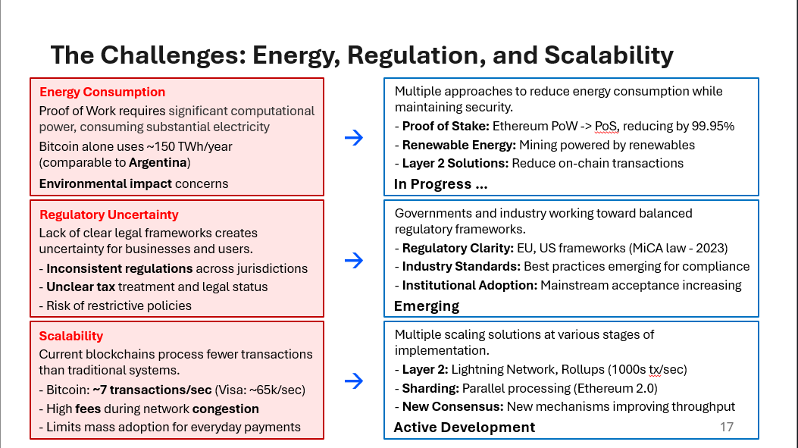
Presenter Notes:
TODO

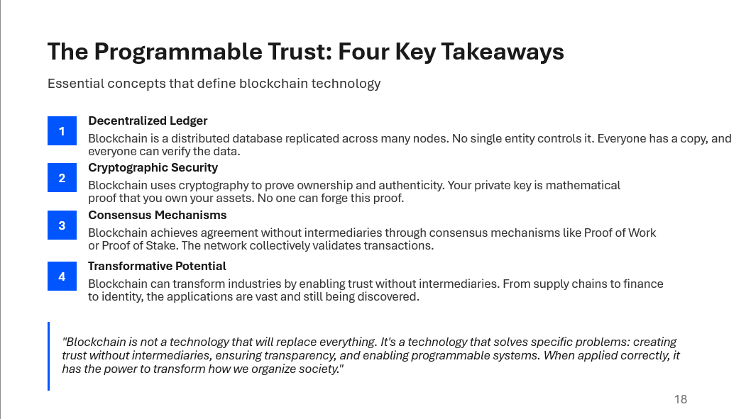
Presenter Notes:
"Let me summarize the four key takeaways. First, blockchain is a decentralized ledger. It's a distributed database replicated across many nodes. No single entity controls it. Everyone has a copy, and everyone can verify the data. Second, blockchain uses cryptographic security. Your private key is mathematical proof that you own your assets. No one can forge this proof. Third, blockchain achieves consensus without intermediaries. Through mechanisms like Proof of Work or Proof of Stake, the network collectively validates transactions. Fourth, blockchain enables programmable trust. Smart contracts embed trust into code. They automatically execute agreements without intermediaries. Trust becomes programmable, transparent, and verifiable. Fifth, blockchain has transformative potential. It can transform industries by enabling trust without intermediaries. From supply chains to finance to identity, the applications are vast. Now, let me be clear about what blockchain is and isn't. Blockchain is not a technology that will replace everything. It's not a get-rich-quick scheme. It's not anonymous. It's not unregulated. Blockchain is a technology that solves specific problems: creating trust without intermediaries, ensuring transparency, and enabling programmable systems. When applied correctly, it has the power to transform how we organize society. The future of blockchain is not about cryptocurrency speculation. It's about building systems that are transparent, verifiable, and trustworthy. Systems where trust is embedded in the code, not in institutions. That's the promise of blockchain. That's the programmable trust."
REDOOOO

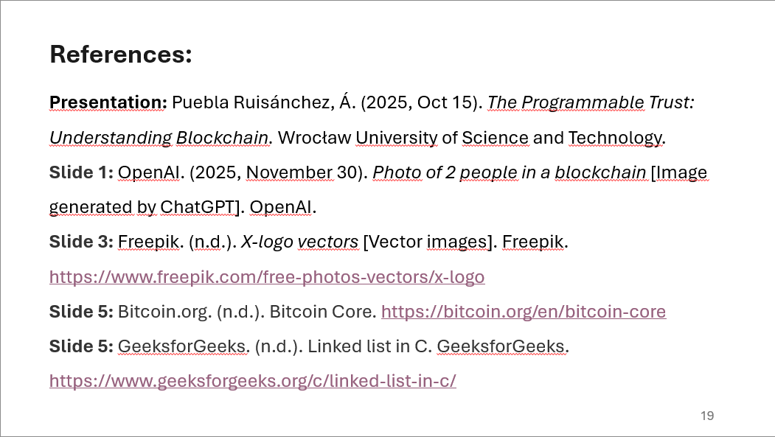
Presenter Notes:
TODO

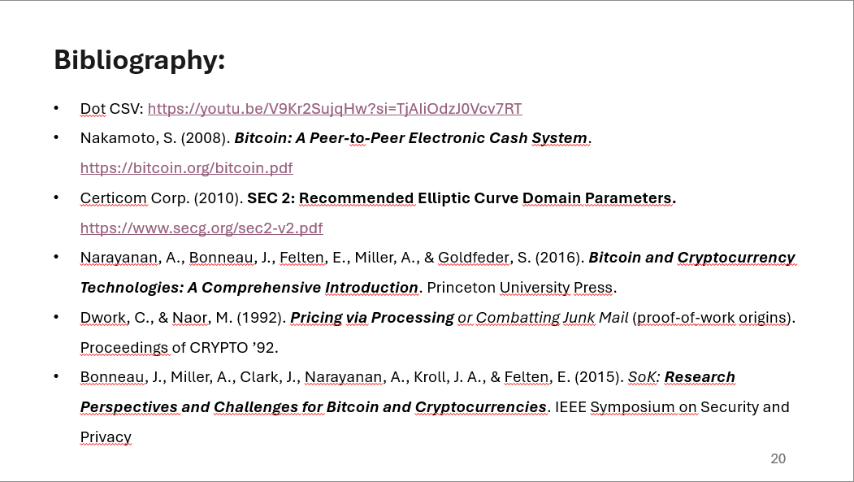
Presenter Notes:
TODO

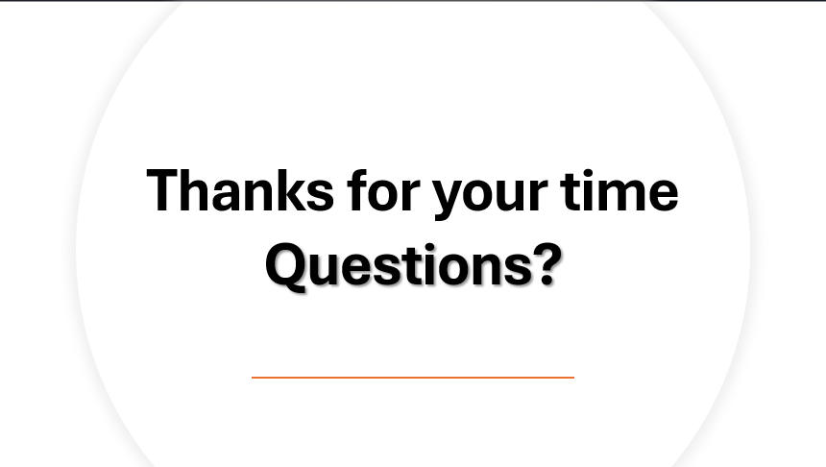
Presenter Notes:
TODO

9 practice questions your teammates can ask you:
1. How does a Merkle root prove a transaction is included in a block?
A Merkle tree organizes all transactions in a block into a binary tree of hashes. To prove a transaction is inside the block, you only need the transaction’s hash and a short set of sibling hashes (the Merkle path). By hashing them step by step you reconstruct the Merkle root. If your computed root matches the block’s root, the transaction is guaranteed to be part of that block without downloading everything.

2. How does Proof of Work prevent double-spending, and why is difficulty adjustment necessary?
Proof of Work makes adding a block expensive, so an attacker must redo enormous amounts of work to rewrite history and double-spend. Honest miners extend the longest chain, so the attacker is always racing against the entire network’s hash power. Difficulty adjustment ensures the puzzle remains hard enough to secure the chain and keeps block times stable, even if hash power suddenly rises or falls.

3. What happens technically and socially when a hard fork is proposed but not everyone upgrades?
Technically, the network splits into two incompatible rule sets, producing two separate chains that no longer recognize each other’s blocks. Socially, the ecosystem has to choose which chain to support—exchanges, wallets, miners, and developers often align around one side. If disagreement persists, two long-term networks can emerge, each with its own community and asset.

4. Why are private keys so critical — what are best practices for key custody?
A private key is the sole proof of ownership of your assets. If someone else gets it, they can spend your funds; if you lose it, you’re permanently locked out. Best practices include using hardware wallets, storing seed phrases offline, avoiding screenshots/cloud storage, enabling multisig for high-value accounts, and having a disaster-recovery backup stored securely.

5. What is a 51% attack, and how would a community detect and respond to one?
A 51% attack occurs when someone controls most of the network’s mining power and can reorganize recent blocks or double-spend. It’s detected through abnormal chain reorgs, sudden orphaned blocks, or mining power concentration. The response typically involves alerting exchanges, increasing confirmation requirements, coordinating miner action, or—in extreme cases—executing a defensive fork.

6. How do mining pools influence decentralization and network security?
Mining pools reduce reward variance for individual miners but concentrate block-production decisions in fewer entities. If a large pool grows too dominant, it becomes a centralization risk because it controls a disproportionate share of hash power. Healthy networks encourage miners to switch pools if one becomes too large and promote pool-level transparency and decentralization.

7. When should you choose a permissioned blockchain over a public one?
Choose a permissioned system when participants are known, compliance is required, data must remain private, or performance and throughput matter more than censorship resistance. Use a public chain when you need trust minimization, open participation, high transparency, and global verifiability.

8. What are the main scalability approaches (on-chain vs off-chain) and their trade-offs?
On-chain scaling increases capacity directly on the base layer (bigger blocks, faster block times). This boosts throughput but increases hardware requirements and reduces decentralization.
Off-chain scaling, like payment channels and rollups, moves computation or transactions outside the base layer while keeping security anchored to it. These scale far better but add architectural complexity and rely on more advanced assumptions.

9. Can blockchain fix all trust problems, or are there cases where centralized systems remain better?
Blockchain removes the need to trust a single party, but it cannot eliminate trust entirely—you still trust the software, the validators, and the governance. Centralized systems remain better when efficiency, low cost, privacy, or legal accountability are priorities. Blockchain shines in environments with low trust, many participants, and a need for transparency or censorship-resistance.

